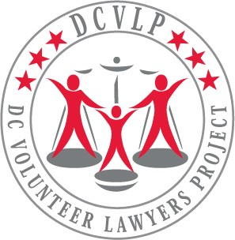

DC Volunteer Lawyers Project
File Retention Form

Name of lawyer submitting files:
Your contact information
Cell phone:
Email address:
Name of Case:
Case #:
Date Opened:
Date Closed:
Supervisor:
Lead Volunteer(s):
Shadow:
For GAL Cases - D.O.B. of youngest child client:
For CPO & DRB Cases - Was there a custody issue?
If so, D.O.B. of youngest child for whom custody was at issue:

